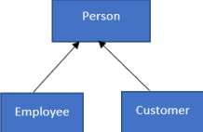

**Class Person**

• string name (private/protected)

• string dob (private/protected)

Constructors, Properties & Methods

• public Person ()

• public Person (string name, string dob)

• public void setName (string name)

• public void setDob (string dob)

• public string getName ()

• public string getDob()

**Class Employee**

• string name (private/protected) //inherited

• string dob (private/protected) //inherited

• Account acc (private/protected)

Constructors, Properties & Methods

• public Employee ()

(int account_id, double amount, string accType)

• public Employee (string name, string dob, Account acc)

• public void setAcc (Account acc)

• public void display ()

**Class Customer**

• string name (private/protected) //inherited

• string dob (private/protected) //inherited

• Account acc (private/protected)

Constructors, Properties & Methods

• public Customer ()

• public Customer (string name, string dob, Account acc)

• public void setAcc (Account acc)

• public void display ()